ACUPUCTURE & CHINESE MEDICINE CLINIC

Notification Form Regarding Evaluation of Patient by Physician

Thank you for coming. Please help us provide you with a complete evaluation by taking the time to fill out this questionnaire carefully. All your information will be confidential. If you have questions, please ask. Thank you.

Full name |  | Sex F M | Date
DOB | Age | Occupation | SSN
E-mail | Home phone | Work phone
Address: Street |  | City | State | Zip
In Emergency, notify |  | Marital status S M D W # of children:
Family physician |  | Chiropractor
Do you have health insurance? Y N |  | Insurance Company
Does your insurance cover acupuncture? Y N |  | Have you ever been treated by acupuncture before? Y N
How did you know this clinic?

Referral ________________________________________ Periodicals Direct mail Location or walk-by Website
Yellow pages Other (Please specify) ________________________________________

Main problem(s):
You would like us to help you with ___________________________________________
When did this problem begin? _______________________________________________
Have you been given diagnosis for this problem? If so, what? ________________________________________________________________________
What kinds of treatment have you tried? _______________________________________
What makes this problem worse? ____________________________________________
What makes this problem better?_ ____________________________________________
Is there anybody in your family with the same/similar problems? ________________________________________________________________________
Past medical history: (Please include the month/year when the diagnosis was established)
Significant illness | Cancer | Diabetes | Hepatitis | Thyroid disease | Seizures
Fibromialgia | Arthritis | Tuberculosis | Hypertension | Emotional imbalance | Anemia
Breathing problems | Heart disease | Digestive disorders | HIV/AIDS Positive | Venereal Disease
Other (please specify)
Surgeries: |  |  | Hospitalization:
Significant trauma: (auto accidents, sports injuries, etc)
Allergies: (drugs, chemicals, foods)

Family medical history: (Please specify family member)
Cancer | Diabetes | Hepatitis | Hypertension | Heart disease | Stroke
Asthma | Alcoholism | Miscarriage | Other (please specify)

Medicines taken within the last two months (including vitamins, OTC drugs, herbs, etc., and their dosages)
________________________________________________________________________

Occupation:
Do you usually work indoors outdoors ?
Occupational stress (chemical, physical, physiological, etc) ______________________________________

Personal:
Height __________ Current weight __________ Weight one year ago __________
Maximum weight __________ in year __________

Habits:
Do you usually smoke? Y N What? _______ How many per day? _______ Since when? _______

Indicate painful or distressed areas:
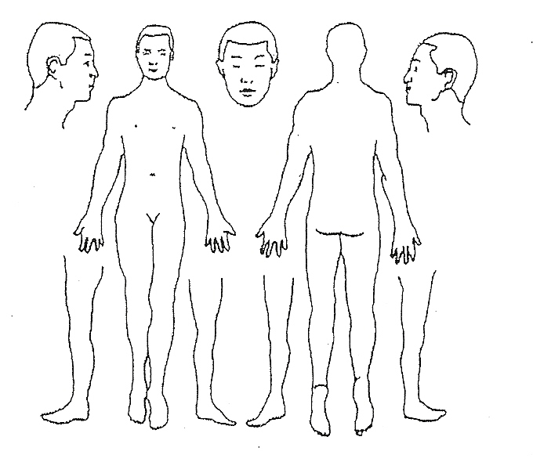
Please check if you have or have had (in the last three months) any of the following diseases or conditions.
General | Poor appetite | Poor sleeping | Fatigue | Fevers | Chills
Night sweats | Tremors | Cravings | Weight loss | Weight gain
Strong thirst (hot or cold drinks)

Skin & hair | Rashes | Ulcerations | Hives | Itching | Eczema
Pimples | Dandruff | Dry skin | Recent moles | Hair loss

Musculoskeletal | Joint disorders | Weak muscles | Pain/soreness in muscles |  | Tremors
Difficulty walking |  | Cold hands/feet |  | Swelling of hands/feet
Numbness | Tingling | Paralysis | Neck tightness | Neck pain | Shoulder pain
Back pain | Spinal curvature |  | Hernia | Knee pain | Sprain of joint
Hand/wrist pain | Hip pain

Head, eyes, ears, nose and throat |  | Dizziness | Migraines |  | Eye strain | Eye pain
Color blindness | Night blindness | Poor vision | Cataracts |  | Blurry vision | Earaches
Ringing in ears | Poor hearing | Spots in front of eyes |  |  | Sinus problems | Sore throat
Grinding teeth | Teeth problems | Facial pain |  | Sores on lips/ tongue
Difficulty swallowing

Cardiovascular | High blood pressure |  | Chest pain | Palpitation | Fainting
Irregular heartbeat |  | Rapid heartbeat |  | Varicose veins

Respiratory | Cough | Coughing blood | Wheezing | Difficulty breathing
Bronchitis | Pneumonia | Chest pain | Production of phlegm – What color? _______________

Gastrointestinal | Nausea | Vomiting | Diarrhea | Constipation | Belching
Black stools | Blood in stools | Indigestion | Bad breath | Hemorrhoids | Parasites
Abdominal pain/ cramps |  | Gallbladder problems |  | Chronic laxative use
Bowel movements: Frequency ____________

Neuro-psychological |  | Loss of balance | Lack of coordination |  | Concussion
Depression | Anxiety | Stress | Bad temper | Bi-polar

Genito-urinary | Pain on urination |  | Frequent urination |  | Blood in urine
Urgency to urinate |  | Kidney stones | Inability to hold urine |  | Dribbling
Pause of flow | Frequent urinary tract infection |  | Pain in genital | Itching of genital
Other

Female | Frequent vaginal infections |  |  | Pelvic infection |  | Endometriosis |  | Fibroids
Vaginal discharge |  |  | Ovarian cysts |  |  | Irregular periods
Clots | Pain/cramps prior to/during periods |  |  |  | Breast tenderness | Breast lumps |  | Hot flashes
Fertility Problems |  |  | Moodiness related to periods
___ number of pregnancies |  | ___ number of births |  |  | ___ miscarriages |  | ___ abortions
___ premature births |  | ___ Cesareans |  |  | ___ Difficult delivery

First date of last period: __________ Age of first menses: ____ Duration of periods: ____ days, cycle ____ days
Do you practice birth control? Y N. If yes, what type and for how long? __________________________________

Male | Prostate problems | Discharge | Impotence | Frequent seminal emission
Fertility problems |  | Ejaculation problems |  | Painful/ swollen testicles
Other

I understand the above information and guarantee this form was completed correctly to the best of my knowledge.
Signature: Adult patient Parent of Guardian Spouse

Notification Form Regarding Evaluation of Patient by Physician

Pursuant to the requirement of section 183.7 (e) of this title and section 6.11, Subsection (d) V. A. C. S. article 4495b, governing the practice of acupuncture)

I __________________________________ ( patient’s name) am notifying the Acupuncture & Chinese Medicine Clinic of following:

Yes ___ No ___ I have been evaluated by a physician or dentist for the condition being treated within twelve (12) months before the acupuncture was performed. I recognize that a physician or dentist should evaluate me for the condition being treated by the acupuncturist. ______ (patient’s initials) Date: ______

Yes ___ No ___ I have received a referral from a chiropractor within the last 30 days for acupuncture. The date of the referral is _________________________, and the most recent date of chiropractic treat prior to acupuncture treatment is
___________________________________. After being referred by a chiropractor, if after 60 days or 20 treatments, whichever comes first, no substantial improvement occurs in the condition being treated, I understand that the acupuncturist is required to refer me to physician. It is my responsibility and choice to follow this advice.

________________________________________________________________________
Patient Signature (required) Date

I have not been evaluated by a physician or dentist for the condition being treated, nor have I received a referral from a chiropractor, but I seek treatment for one of the following conditions:

___ Chronic Pain
___ Weight Loss
___ Smoking Cessation

________________________________________________________________________
Patient Signature (required) Date

The Acupuncture & Chinese Medicine Clinic is not responsible for untrue statements made by patient.

Request and consent

I hereby request Shuangzhu Qin L.Ac. to treat me. I also authorize her to perform on me the treatment known as Acupuncture as her judgment may indicate and authorize her to use whatever therapeutic methods she may see fit. Whether or not such methods are commonly and generally accepted and practiced in this community.

Shuangzhu Qin has frankly and fully explained to me the nature and purpose of the treatment, the risks involved, including but not limited to mild bruise from needling, possible burns from moxibustion. In giving my consent to the treatment, I have in mind her frank and full explanation. If any unforeseen condition arises in the course of treatment and in the judgment of the Acupuncturist it is advisable to use procedures in addition to or different from those now contemplated, I also request and authorize her to do whatever she deems advisable.

If you are suffering from any of the following diseases/conditions, please notify the acupuncturist at this time:
- Heart condition
- Diabetes
- Fainting from needles
- Bruise easily
- Stroke
- Please confirm that the acupuncturist has shown you the disposable needles. Yes

In the event that my condition is such that treatment is beyond the normal capabilities of the acupuncturist. I understand that I may be referred to other competent practitioners including, but not necessarily limited to, medical physicians or other acupuncturist.

I also agree to give 24 hours notice if I am going to be unable to make my scheduled appointment. I fully understand I will be charged the regular fee if I miss an appointment without giving 24 hours notice.

______________________ ______________________________
Date Signature of Patient

